STAR LION COLLEGE OF ENGINEERING AND TECHNOLOGY

|  |  |
| --- | --- |
| Date | 26/10/2023 |
| Name | K.Anushiya |
| Department | Computer Science and Engineering |
| Project | Create A Chatbot In Python |
| Register number | 822021104002 |
| Naan mudhalvan ID | au822021104002 |

CREATE A CHATBOT IN PYTHON

Phase_4 Document Submission

**PROJECT:** Create A Chat bot In Python

**Object Detection With YOLO:**

Object detection is a popular task in computer vision.

It deals with localizing a region of interest within an image and classifying this region like a typical image classifier. One image can include several regions of interest pointing to different objects. This makes object detection a more advanced problem of image classification.

YOLO (You Only Look Once) is a popular object detection model known for its speed and accuracy. It was first introduced by Joseph Red mon et al. in 2016 and has since undergone several iterations, the latest being YOLO v7.

In this article, we will discuss what makes YOLO v7 stand out and how it compares to other object detection algorithms.

Object detection is a computer vision task that involves identifying and locating objects in images or videos. It is an important part of many applications, such as surveillance, self-driving cars, or robotics. Object detection algorithms can be divided into two main categories: single-shot detectors and two-stage detectors.

One of the earliest successful attempts to address the object detection problem using deep learning was the R-CNN (Regions with CNN features) model, developed by Ross Gir shick and his team at Microsoft Research in 2014. This model used a combination of region proposal algorithms and convolutional neural networks (CNNs) to detect and localize objects in images.

Object detection algorithms are broadly classified into two categories based on how many times the same input image is passed through a network.

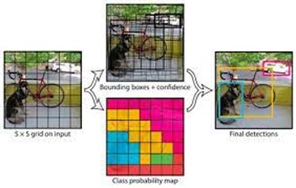

**Single-shot object detection:**

Single-shot object detection uses a single pass of the input image to make predictions about the presence and location of objects in the image. It processes an entire image in a single pass, making them computationally efficient.

However, single-shot object detection is generally less accurate than other methods, and it’s less effective in detecting small objects. Such algorithms can be used to detect objects in real time in resource-constrained environments.

YOLO is a single-shot detector that uses a fully convolutional neural network (CNN) to process an image. We will dive deeper into the YOLO model in the next section.

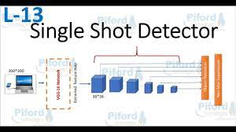

**Two-shot object detection:**

Two-shot object detection uses two passes of the input image to make predictions about the presence and location of objects. The first pass is used to generate a set of proposals or potential object locations, and the second pass is used to refine these proposals and make final predictions. This approach is more accurate than single-shot object detection but is also more computationally expensive.

Overall, the choice between single-shot and two-shot object detection depends on the specific requirements and constraints of the application.

Generally, single-shot object detection is better suited for real-time applications, while two-shot object detection is better for applications where accuracy is more important.

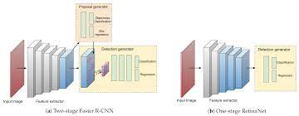

Object detection models performance evaluation metrics

To determine and compare the predictive performance of different object detection models, we need standard quantitative metrics.

The two most common evaluation metrics are Intersection over Union (Io U) and the Average Precision (AP) metrics.

**Intersection over Union (Io U)**

Intersection over Union is a popular metric to measure localization accuracy and calculate localization errors in object detection models.

To calculate the Io U between the predicted and the ground truth bounding boxes, we first take the intersecting area between the two corresponding bounding boxes for the same object. Following this, we calculate the total area covered by the two bounding boxes— also known as the “Union” and the area of overlap between them called the “Intersection.”

The intersection divided by the Union gives us the ratio of the overlap to the total area, providing a good estimate of how close the prediction bounding box is to the original bounding box.

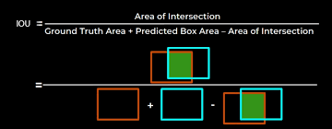

**Recurrent Neural Networks:**

A recurrent neural network (RNN) is a type of artificial neural network which uses sequential data or time series data. These deep learning algorithms are commonly used for ordinal or temporal problems, such as language translation, natural language processing (nlp), speech recognition, and image captioning; they are incorporated into popular applications such as Siri, voice search, and Google Translate. Like feedforward and convolutional neural networks (CNNs), recurrent neural networks utilize training data to learn. They are distinguished by their “memory” as they take information from prior inputs to influence the current input and output. While traditional deep neural networks assume that inputs and outputs are independent of each other, the output of recurrent neural networks depend on the prior elements within the sequence. While future events would also be helpful in determining the output of a given sequence, unidirectional recurrent neural networks cannot account for these events in their predictions.

Let’s take an idiom, such as “feeling under the weather”, which is commonly used when someone is ill, to aid us in the explanation of RNNs. In order for the idiom to make sense, it needs to be expressed in that specific order. As a result, recurrent networks need to account for the position of each word in the idiom and they use that information to predict the next word in the sequence.

Another distinguishing characteristic of recurrent networks is that they share parameters across each layer of the network. While feedforward networks have different weights across each node, recurrent neural networks share the same weight parameter within each layer of the network. That said, these weights are still adjusted in the through the processes of backpropagation and gradient descent to facilitate reinforcement learning.

Recurrent neural networks leverage backpropagation through time (BPTT) algorithm to determine the gradients, which is slightly different from traditional backpropagation as it is specific to sequence data. The principles of BPTT are the same as traditional backpropagation, where the model trains itself by calculating errors from its output layer to its input layer. These calculations allow us to adjust and fit the parameters of the model appropriately. BPTT differs from the traditional approach in that BPTT sums errors at each time step whereas feedforward networks do not need to sum errors as they do not share parameters across each layer.

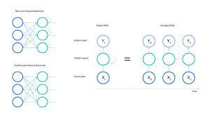

**Types of recurrent neural networks:**

Feedforward networks map one input to one output, and while we’ve visualized recurrent neural networks in this way in the above diagrams, they do not actually have this constraint. Instead, their inputs and outputs can vary in length, and different types of RNNs are used for different use cases, such as music generation, sentiment classification, and machine translation.

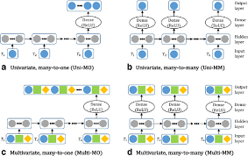

**Common activation functions:**

As discussed in the Learn article on Neural Networks, an activation function determines whether a neuron should be activated. The nonlinear functions typically convert the output of a given neuron to a value between 0 and 1 or -1 and 1.

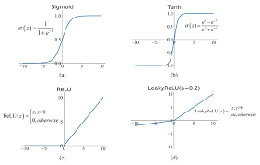

**Variant RNN architectures:**

Bidirectional recurrent neural networks (BRNN): These are a variant network architecture of RNNs. While unidirectional RNNs can only drawn from previous inputs to make predictions about the current state, bidirectional RNNs pull in future data to improve the accuracy of it. If we return to the example of “feeling under the weather” earlier in this article, the model can better predict that the second word in that phrase is “under” if it knew that the last word in the sequence is “weather.”



**Recurrent neural networks and IBM Cloud:**

For decades now, IBM has been a pioneer in the development of AI technologies and neural networks, highlighted by the development and evolution of IBM Watson. Watson is now a trusted solution for enterprises looking to apply advanced natural language processing and deep learning techniques to their systems using a proven tiered approach to AI adoption and implementation.

IBM products, such as IBM Watson Machine Learning, also support popular Python libraries, such as Tensor Flow, Ker a s, and Py Torch, which are commonly used in recurrent neural networks. Utilizing tools like, IBM Watson Studio and Watson Machine Learning, your enterprise can seamlessly bring your open-source AI projects into production while deploying and running your models on any cloud.

Architecture of a traditional RNN Recurrent neural networks, also known as RNNs, are a class of neural networks that allow previous outputs to be used as inputs while having hidden states.

This article was published as a part of the Data Science Blo gathon.

Apple’s Siri and Google’s voice search both use Recurrent Neural Networks (RNNs), which are the state-of-the-art method for sequential data. It’s the first algorithm with an internal memory that remembers its input, making it perfect for problems involving sequential data in machine learning. It’s one of the algorithms responsible for the incredible advances in deep learning over the last few years. In this article, we’ll go over the fundamentals of recurrent neural networks, as well as the most pressing difficulties and how to address them.

**Introduction on Recurrent Neural Networks:**

A Deep Learning approach for modelling sequential data is Recurrent Neural Networks (RNN). RNNs were the standard suggestion for working with sequential data before the advent of attention models. Specific parameters for each element of the sequence may be required by a deep feedforward model. It may also be unable to generalize to variable-length sequences.

**Recurrent Neural Networks:**

Source: Medium.com

Recurrent Neural Networks use the same weights for each element of the sequence, decreasing the number of parameters and allowing the model to generalize to sequences of varying lengths. RNNs generalize to structured data other than sequential data, such as geographical or graphical data, because of its design.

Recurrent neural networks, like many other deep learning techniques, are relatively old. They were first developed in the 1980s, but we didn’t appreciate their full potential until lately. The advent of long short-term memory (LSTM) in the 1990s, combined with an increase in computational power and the vast amounts of data that we now have to deal with, has really pushed RNNs to the forefront.

**Natural Language Processing:**

Natural language processing (NLP) refers to the branch of computer science—and more specifically, the branch of artificial intelligence or AI—concerned with giving computers the ability to understand text and spoken words in much the same way human beings can.

NLP combines computational linguistics—rule-based modeling of human language—with statistical, machine learning, and deep learning models. Together, these technologies enable computers to process human language in the form of text or voice data and to ‘understand’ its full meaning, complete with the speaker or writer’s intent and sentiment.

NLP drives computer programs that translate text from one language to another, respond to spoken commands, and summarize large volumes of text rapidly—even in real time. There’s a good chance you’ve interacted with NLP in the form of voice-operated GPS systems, digital assistants, speech-to-text dictation software, customer service chat bots, and other consumer conveniences. But NLP also plays a growing role in enterprise solutions that help streamline business operations, increase employee productivity, and simplify mission-critical business processes.

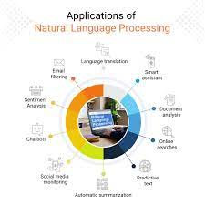

**NLP tasks:**

Human language is filled with ambiguities that make it incredibly difficult to write software that accurately determines the intended meaning of text or voice data. Homonyms, homophones, sarcasm, idioms, metaphors, grammar and usage exceptions, variations in sentence structure—these just a few of the irregularities of human language that take humans years to learn, but that programmers must teach natural language-driven applications to recognize and understand accurately from the start, if those applications are going to be useful.

Several NLP tasks break down human text and voice data in ways that help the computer make sense of what it's ingesting. Some of these tasks include the following:

Speech recognition, also called speech-to-text, is the task of reliably converting voice data into text data. Speech recognition is required for any application that follows voice commands or answers spoken questions. What makes speech recognition especially challenging is the way people talk—quickly, slurring words together, with varying emphasis and intonation, in different accents, and often using incorrect grammar.

Part of speech tagging, also called grammatical tagging, is the process of determining the part of speech of a particular word or piece of text based on its use and context. Part of speech identifies ‘make’ as a verb in ‘I can make a paper plane,’ and as a noun in ‘What make of car do you own?’

Word sense disambiguation is the selection of the meaning of a word with multiple meanings through a process of semantic analysis that determine the word that makes the most sense in the given context. For example, word sense disambiguation helps distinguish the meaning of the verb 'make' in ‘make the grade’ (achieve) vs. ‘make a bet’ (place).

Named entity recognition, or NEM, identifies words or phrases as useful entities. NEM identifies ‘Kentucky’ as a location or ‘Fred’ as a man's name.

Co-reference resolution is the task of identifying if and when two words refer to the same entity. The most common example is determining the person or object to which a certain pronoun refers (e.g., ‘she’ = ‘Mary’), but it can also involve identifying a metaphor or an idiom in the text (e.g., an instance in which 'bear' isn't an animal but a large hairy person).

Sentiment analysis attempts to extract subjective qualities—attitudes, emotions, sarcasm, confusion, suspicion—from text.

Natural language generation is sometimes described as the opposite of speech recognition or speech-to-text; it's the task of putting structured information into human language.

See the blog post “NLP vs. NLU vs. NLG: the differences between three natural language processing concepts” for a deeper look into how these concepts relate.

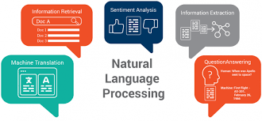

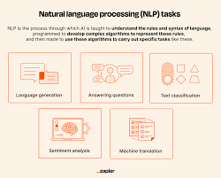

**NLP tools and approaches:**

**Python and the Natural Language Toolkit (NLTK):**

The Python programing language provides a wide range of tools and libraries for attacking specific NLP tasks. Many of these are found in the Natural Language Toolkit, or NLTK, an open source collection of libraries, programs, and education resources for building NLP programs.

The NLTK includes libraries for many of the NLP tasks listed above, plus libraries for subtasks, such as sentence parsing, word segmentation, stemming and lemmatization (methods of trimming words down to their roots), and tokenization (for breaking phrases, sentences, paragraphs and passages into tokens that help the computer better understand the text). It also includes libraries for implementing capabilities such as semantic reasoning, the ability to reach logical conclusions based on facts extracted from text.

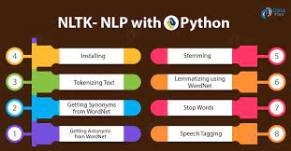

**NLP use cases:**

Natural language processing is the driving force behind machine intelligence in many modern real-world applications.

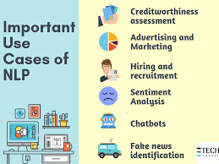

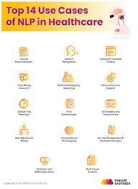

Here are a few examples:

**Spam detection:** You may not think of spam detection as an NLP solution, but the best spam detection technologies use NLP's text classification capabilities to scan emails for language that often indicates spam or phishing. These indicators can include overuse of financial terms, characteristic bad grammar, threatening language, inappropriate urgency, misspelled company names, and more. Spam detection is one of a handful of NLP problems that experts consider 'mostly solved' (although you may argue that this doesn’t match your email experience).

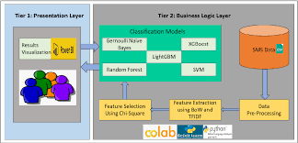

**Machine translation:** Google Translate is an example of widely available NLP technology at work. Truly useful machine translation involves more than replacing words in one language with words of another. Effective translation has to capture accurately the meaning and tone of the input language and translate it to text with the same meaning and desired impact in the output language. Machine translation tools are making good progress in terms of accuracy. A great way to test any machine translation tool is to translate text to one language and then back to the original. An oft-cited classic example: Not long ago, translating “The spirit is willing but the flesh is weak” from English to Russian and back yielded “The vodka is good but the meat is rotten.” Today, the result is “The spirit desires, but the flesh is weak,” which isn’t perfect, but inspires much more confidence in the English-to-Russian translation.

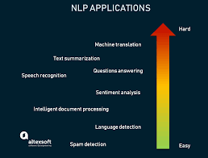

**Virtual agents and chat bots:** Virtual agents such as Apple's Siri and Amazon's Alexa use speech recognition to recognize patterns in voice commands and natural language generation to respond with appropriate action or helpful comments. Chat bots perform the same magic in response to typed text entries. The best of these also learn to recognize contextual clues about human requests and use them to provide even better responses or options over time. The next enhancement for these applications is question answering, the ability to respond to our questions—anticipated or not—with relevant and helpful answers in their own words.

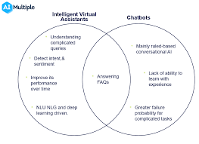

**Social media sentiment analysis:** NLP has become an essential business tool for uncovering hidden data insights from social media channels. Sentiment analysis can analyze language used in social media posts, responses, reviews, and more to extract attitudes and emotions in response to products, promotions, and events–information companies can use in product designs, advertising campaigns, and more.

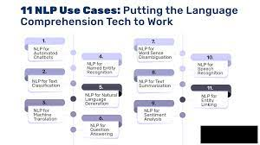

**Text summarization:** Text summarization uses NLP techniques to digest huge volumes of digital text and create summaries and synopses for indexes, research databases, or busy readers who don't have time to read full text. The best text summarization applications use semantic reasoning and natural language generation (NLG) to add useful context and conclusions to summaries.

